**EXPERIMENT NO. 3**

|  |
| --- |
| **Student Name and Roll Number: Avtar Singh - 20CSU241** |
| **Semester /Section: 5th / FSB** |
| **Link to Code:** |
| **Date: 24/08/2022** |
| **Faculty Signature:** |
| **Marks:** |

|  |
| --- |
| **Objective:**  To write the shell programming code for the following. |
| **Outcome:**  Student is able to write code in shell programming |
| **Problem Statement:**  a) Write a shell program to find Fibonacci series.  b) Write a shell program to find largest of three numbers.  c) Write a shell program to find average of N numbers |
| **Background Study:**  A shell script is a file with a set of commands in it. The shell reads this file and executes the instructions as if they were input directly on the command line.  A shell is a command-line interpreter and operations such as file manipulation, program execution and text printing is performed by shell script. So, we will use vi editor to edit our files. |
| **Question Bank:**   1. How to use multi line comments in shell script?   Ans : In Shell or Bash shell, we can comment on multiple lines **using << and name of comment**. we start a comment block with << and name anything to the block and wherever we want to stop the comment, we will simply type the name of the comment.   1. What is the difference between soft and hard links?   Ans : A hard link is a file all its own, and the file references or points to the exact spot on a hard drive where the Inode stores the data. A soft link isn't a separate file, it points to the name of the original file, rather than to a spot on the hard drive.   1. Explain about loops and what are the loops available in LINUX?   Ans : The for loop **operates on lists of items**. It repeats a set of commands for every item in a list.  There are **three types of shell loops** in UNIX/Linux: for loop. while loop. until loop.  You will use different loops based on the situation. For example, **the while loop executes the given commands until the given condition remains true; the until loop executes until a given condition becomes true**.   1. What are absolute and relative paths.   Ans : **An absolute path is defined as specifying the location of a file or directory from the root directory(/)**. In other words,we can say that an absolute path is a complete path from start of actual file system from / directory. Relative path is defined as the path related to the present working directly(pwd).   1. How to debug a shell script.   Ans : The debugging options available in the Bash shell can be switched on and off in multiple ways. Within scripts, we can either use the set command or add an option to the shebang line. However, another approach is to explicitly specify the debugging options in the command-line while executing the script. |

**Student Work Area**

**Algorithm/Flowchart/Code/Sample Outputs**

a) Write a shell program to find Fibonacci series.

Program :

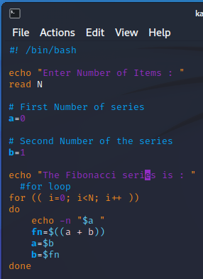

Output :

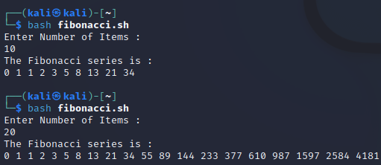

b) Write a shell program to find largest of three numbers.

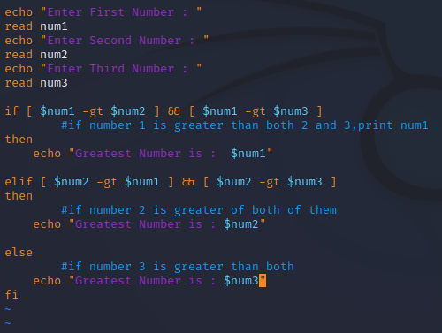

OUTPUT :

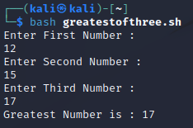

c) Write a shell program to find average of N numbers

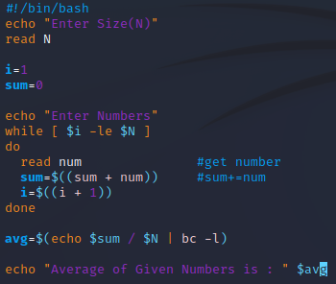

**Output :**

